Erne Integrated College

5 Derrygore Road
Enniskillen
Co Fermanagh
BT74 4FW

Post of Principal

Candidate Information Pack

Contents:

- Introduction

- Appointment Process

- Key Dates

Appendices

- Job Description

- Person Specification

- Terms and Conditions of Appointment

(d) Extract from the Scheme of Management for GMI schools

The Board of Governors invites applications for the full-time post of Principal of Erne Integrated College.

Application forms are to be completed in full and returned via email
by: Monday 8th April 2024 at 12.00noon to: hholleran350@c2ken.net
- Introduction
The Board of Governors wishes to appoint to the full-time permanent post of Principal a person who has the knowledge, skills, understanding and experience to lead the school into the next phase of its development, building on the founding ethos and achievements so far.
2 Appointment Process
The process for the appointment of the principal will be undertaken by a sub-committee of the Board of Governors, led by the chair of governors.
Candidates will be judged as to their suitability for the post through a two stage process, namely:
1. Shortlisting: to assess a candidate’s qualifications and experience, based on the Shortlisting Criteria set out below, and on the evidence provided by the candidate on the Application Form.
2. Interview: to allow candidates to expand on the contribution they would make in the role of principal of Erne Integrated College in the light of the information provided in the Job Description and the Person Specification at Appendices A and B below.

For further information, the Conditions of Service are included in Appendix C and an extract from the Scheme of Management for GMI schools in Appendix D.
Canvassing of any kind on behalf of a candidate will result in disqualification.
All fully completed applications received by the due closing date and time will be assessed on the basis of the information supplied against the shortlisting criteria set out below. A shortlist of applicants will be drawn up and those shortlisted invited to attend for interview.
Candidates should ensure that all the essential and desirable criteria are clearly addressed on the application form providing dates and evidence as appropriate.

Shortlisting Criteria

JOB TITLE: PRINCIPAL SCHOOL: ERNE INTEGRATED COLLEGE
ETHOS | Essential | A commitment to integrated, all-ability, inclusive and child centred education. A commitment to equality of opportunity and working in partnership with governors, parents, students and the local community.
 | Desirable | Have previous involvement in cross-community/multi-cultural activities either inside an education framework or within the wider community.
EDUCATIONAL and PROFESSIONAL QUALIFICATIONS  AT COMMENCEMENT OF EMPLOYMENT | Essential | An honours degree or higher degree.  Qualified teacher status (as recognised by DE) with a minimum of 8 years* post primary school teaching experience as at 31st August 2024. At least 2 years* within the past 5 years* as of 31st August 2024 experience at senior management level (Head of Department or above) with responsibility for strategic development (in education and/or other contexts)  If successful be registered with the GTCNI by the agreed date of taking up duty.
 | Desirable | Have successfully completed or currently undertaking relevant training or qualification for principalship, or are currently serving as Principal or Vice Principal.
PREVIOUS EXPERIENCE/  TRAINING | Essential | Have at least 5 years* experience as of 31st August 2024 within the last 8 years* of the NI/UK Curriculum at the post-primary school Key Stages: 3, 4 or 5. This experience will have been gained through working in teaching or other NI/UK curricular related area.
 | Desirable | Experience and expertise in some or all of the following: - assessment, staff development, financial management, curricular development, special needs, liaison with external agencies at a senior level, public relations.
JOB-RELATED ACHIEVEMENTS | Essential | Successful leadership and management experience in education and/or other contexts. Experience of dealing with whole school issues.
 | Desirable | Have a proven ability to meet tight deadlines.
INTER-PERSONAL SKILLS | Essential | Excellent oral and written communication skills. High level of people, team and organisational skills, self motivation and enthusiasm. Ability to engender the respect and confidence of the school and local community.
 | Desirable | Experience and skill in dealing with agencies associated with the school.

* Year equates to the school year 1st September to 31stAugust.
The selection panel reserves the right to enhance the criteria to facilitate short-listing.
Posts involving work with children and young people in educational establishments are subject to the provisions of the Safeguarding Vulnerable Groups (NI) Order 2007.
Interview
References
Applicants are required to identify three referees in their application forms, Referees should be in a position to comment on a candidate’s professional role and experience. Referees will be approached after candidates have been shortlisted. A referee should not be related to the candidate.
Interview
Candidates will be interviewed by the subcommittee of the Board of Governors. Further details of the interview process will be provided to shortlisted candidates.
- Key Dates
The key dates for applicants associated with the selection and appointment process are as follows:
Closing date and time for receipt of applications: Monday 8th April 2024, 12.00noon
Shortlisting: Tuesday 9th April 2024
Interviews: Thursday 18th April 2024
Report to and ratification by the Board of Governors: Monday 22nd April 2024
Commencement of employment as principal 1st September 2024

APPENDIX A
Job Description
- The person appointed to the post of principal at Erne Integrated College will provide effective, professional leadership focused on the founding ethos of the school, ensuring that every student has the opportunity to fulfil their potential.
- Working with the Board of Governors and colleagues, the principal as lead professional will articulate a clear sense of purpose and direction and offer the leadership and management to ensure achievement and the smooth running of the school.
- The principal will be responsible for creating a secure, productive and disciplined learning environment and for the day to day management of the school. The principal will report to and be accountable to the Board of Governors, which is the managing authority for Erne Integrated College.
- The roles and responsibilities of the principal in a Grant Maintained Integrated School are complex and wide ranging. The school’s budget is fully delegated, and the Board of Governors is the employer of all support staff. The summary of responsibilities outlined below is not exhaustive, but identifies the knowledge, skills and personal capabilities that are considered important for the post of principal of Erne Integrated College:
- Maintaining the ethos
- Shaping the future
- Leading learning and teaching
- Leading and developing the staff team
- Leading and managing the organisation
- Accountability
- Maintaining the Ethos
The principal is the embodiment of the ethos, fulfilling the vision of the founding parents. The principal leads by example in Integration and ensures that the founding ethos is lived throughout the school. This involves:
- Sustaining Integration as a dynamic and holistic process;
- Developing and challenging relationships among students, staff, parents/carers, governors and members of the wider school community;
- Reviewing and implementing the pastoral policy to provide a safe, challenging and supportive learning environment for everyone in the school, and ensuring full compliance with all legislative and statutory requirements;
- Advising and supporting parents/carers in every aspect of their child’s life and education within the school;
- Addressing behavioural issues which disrupt or damage the experience of the student and of others in the school;
- Developing and supporting the extra-curricular programme, ensuring Integration, inclusion, challenge and support;
- Supporting extra-curricular events and activities;
- Monitoring, reviewing and evaluating school policies and practices, ensuring that they are compliant with legislation and statute, and taking account of new challenges and opportunities;
- Advising the Board of Governors on all professional matters relating to the running of the school;
- Advising the Board of Governors in the admissions policy and process, ensuring the centrality of religious/cultural balance;
- Communicating proactively with parents/carers, both individually and as a body, keeping them fully informed about the life of the school and also about their child’s progress and achievement.
- Shaping the Future
The principal is responsible for working with the Board of Governors, students, staff, parents/carers and the wider school community in fulfilling the shared vision of the school. This responsibility requires strategic thinking, the ability to articulate the vision, to motivate others and the ability to turn ideas into action. This involves:
- Leading by example, embodying the vision and ethos of the school, ensuring that they are clearly articulated, shared, understood and acted upon by students, staff, parents/carers, governors and members of the wider school community;
- Ensuring strategic planning processes enable the school to address new challenges, establish priorities for the future and sustain school improvement;
- Ensuring the School Development Plan reflects the long term aims of the school and clearly articulates short and medium term goals and plans;
- Sustaining the highest expectations for all our students, planning for the challenge and support they need to fulfil their personal and academic potential;
- Working alongside staff to ensure that goals align with strategy and that learning and working together is a dynamic, holistic process;
- Leading the school in addressing the challenges of change, in the context of a declining level of funding;
- Managing the finances, organisation and administration of the school in ways that support both integration and learning.

- Leading Learning and Teaching
The principal is responsible for ensuring the provision of an excellent educational experience at Erne, based on a dynamic curriculum, on excellent teaching and on enthusiasm for learning. This involves:
- Creating and sustaining an environment which promotes good learning and teaching, high standards of academic achievement and creative and productive learning;
- Putting learning at the centre of strategic planning and resource management;
- Maintaining a current knowledge of teaching and learning methods, curriculum development, syllabus change, new and emerging technologies and other approaches which support good learning and teaching;
- Teaching as required;
- Monitoring and evaluating the quality of learning and teaching, and the standards of student achievement, ensuring that targets are aspirational and enabling;
- Challenging underperformance at all levels;
- Ensuring the curriculum provided is open to all students, that there are high expectations of all students and that the challenge and support required is provided;
- Sustaining careers provision as central both to the educational experience of students and to curriculum development within the school;
- Sustaining good relationships with parents/carers in order to fully support learning and a full experience of school life;
- Developing links with the wider community and educational world to enhance the educational experience at the school;
- Ensuring a rich offer of curriculum, extra-curricular activities and enrichment is available to all students;
- Supporting community use of school facilities in order to support Integration within the community and provide a shared space.
- Leading and Developing the Staff
The principal is responsible for directly managing all staff within the school. This responsibility requires a leadership style which involves the following:
- Managing leaders throughout the staff, providing guidance to those with particular responsibilities and supporting them in leading and managing other staff;
- Maximising the contribution of staff to developing the learning experience of students;
- Fostering and encouraging the contribution made by staff beyond the school day through extra-curricular activities;
- Planning, allocating, supporting and evaluating work done by groups of staff and individuals, ensuring clear delegation of both responsibility and authority;
- Sustaining effective systems for managing staff performance, incorporating performance review, including aspects relating to student achievement and staff development;
- Ensuring that professional duties and responsibilities are fulfilled and that the terms and conditions of employment for all staff are observed;
- Encouraging staff at all levels through appropriate professional development and training;
- Working with the Board of Governors to review staffing structures to meet the developing needs of the school;
- Working with the Board of Governors to recruit staff of the highest calibre.
- Leading and Managing the Organisation
The principal is responsible for providing leadership and effective organisation and management of the school, including overall responsibility for financial matters. This involves:
- Maintaining an organisational structure and culture which reflects the values of Integration and to which students, staff, parents/carers and governors can subscribe;
- Leading the safeguarding team and ensuring the implementation of all safeguarding matters as outlined in the annual return;
- Adopting rigorous self-evaluation procedures in order to enable the school to function as an efficient, effective and safe learning environment;
- Working with other staff to ensure the efficient and effective deployment of resources in such a way as to promote the best possible quality of education;
- Working closely with the Finance Officer to set and manage the school budget to meet the school’s aims and financial targets, setting priorities for expenditure, allocating funds accordingly and ensuring effective monitoring and control;
- Reviewing regularly financial management reports and working with the Finance Committee of the Board of Governors to take appropriate action to run the school within the budget set;
- Managing, monitoring and reviewing all available resources to ensure that the best quality of education is provided in the context of budgetary constraints, while also securing best possible value for money;
- Ensuring all policies are up to date and in line with best practice, fully implementing policy and ensuring that risk assessments are undertaken regularly;
- Ensuring that the school’s premises and estate are safe, well presented and maintained and are developed to meet the strategic needs of the school;
- Attending all meetings of the Board of Governors and meetings of its committees;
- Convening meetings as appropriate to the needs and good management of the school, ensuring that meetings are minuted and that agreed decisions are implemented and reported to the Board of Governors.
- Being Accountable
The principal is accountable to the Board of Governors for educational outcomes. This involves the following:
- Providing information, guidance and advice to the Board of Governors and its committees so that they are able to meet their responsibilities;
- Creating and sustaining an organisation in which all members of staff feel that they are accountable for success and achievement in the school;
- Collecting objective data and analysing the strengths and weaknesses of the school with a rigorous self-evaluation process;
- Presenting a coherent and accurate account of the school’s performance in formats appropriate to a range of audiences, following guidance given by the Department of Education of NI and ETI;
- Ensuring that parents and students are well-informed about the curriculum and progress being made and that they are able to understand the importance of realistic but challenging targets for improvement and their roles in achieving them;
- Understanding the statutory educational frameworks, governance and lines of accountability, including the role of auditors, assurance systems, ETI and self-evaluation.

Appendix B
Person Specification
This person specification sets out the experience, qualifications, skills, knowledge, abilities, personal attributes, behaviours and competencies that are required by the person to be appointed to the post of principal at Erne Integrated College.
These are over and above the qualifications and experience defined by the shortlisting criteria and shortlisted candidates will be assessed from the completed Application Forms and at interview. The requirements are summarised under the following broad headings:
- Professional knowledge and understanding;
- Experience and responsibility;
- Personal skills and attributes.
Professional Knowledge and Understanding
The person appointed to this post will need to demonstrate a range of knowledge and understanding of the following:
- The value of an Integrated, inclusive and holistic education;
- The main challenges and opportunities in Integrated education in Northern Ireland;
- The main educational challenges and opportunities facing post-primary schools in Northern Ireland;
- The opportunities and pressures for young people;
- The features of good quality educational provision, including the characteristics of effective schools;
- The use of comparative data to understand the educational context in which our school operates;
- Legal matters, in particular those associated with recruitment, safeguarding, equality, health and safety and the management of finance;
- The Integrated sector.
Experience and Responsibility
The person appointed to this post will need to demonstrate significant experience of, and responsibility in the following areas:
- Leading and managing change and improvement in pursuit of strategic objectives on a whole school basis;
- Building, leading and supporting cohesive and effective teams;
- Corporate responsibility and decision making;
- Curriculum and pastoral development; staff development; financial management;
- Developing effective links with external agencies, FE and HE institutions and employers.
Personal Skills and Attributes
The person appointed will need to be able to demonstrate the following key skills and attributes:
- A strong commitment to Integrated, academically excellent, all-ability, student centred and parent supportive education;
- Ability to lead Integration by example as a dynamic process.
Communication Skills
- Excellent communication and interpersonal skills, including oral, written and listening skills;
- Ability to negotiate, consult and chair meetings effectively;
- Ability to deal sensitively with people and resolve conflict;
- High levels of ICT skills.
Analytical Skills
- Strong analytical skills and the ability to lead strategic development;
- Ability to investigate, solve problems, identify priorities and make sound decisions and recommendations to the Board of Governors, based on objective evidence.
Organisational and Management Skills
- High level organisational skills and the ability to cope with pressure and to manage workload effectively;
- Ability to build, support and work with cohesive and productive teams, devolving responsibilities, delegating tasks and monitoring outcomes;
- Ability to work under pressure and retain a sense of perspective and proportion;
- Ability to plan and manage the effective use of resources, including time, staff and money;
- Have the flexibility to review and implement changes as appropriate.

APPENDIX C
Terms and Conditions of Appointment
Introduction
The successful applicant for the position of principal will be expected to carry out the duties and responsibilities outlined in the accompanying job description (see Appendix A) and will be paid a salary based on the Leadership Scale L20-L27 commensurate with their experience and qualifications.
There is an expectation that the person appointed will have the capacity to develop skills, competencies and understanding to enable her/him to carry out the full range of duties associated with the post.
Terms and Conditions
The terms and conditions of service for the person appointed to the post will be based on those which apply to principals of all grant aided schools in Northern Ireland. They are set out in The Teachers’ (Terms and Conditions of Employment) Regulations (NI) 1987, as amended (commonly referred to as the Jordanstown Agreement) and in subsequent statements by the Department of Education.
A copy of Schedule 1 of the Regulations is attached at the end of this Appendix for information purposes and should be read in conjunction with the Job Description.
Under a determination made by the Department of Education Northern Ireland the college falls within Group 4 with the salary range being from points 20-27 on the Leadership Scale. The Individual School Range and the precise point on the ISR will be determined by the board of governors taking account of the successful applicant’s qualifications, experience, current salary position, and overall suitability for the post.
Confirmation of Appointment
Candidates will be required to provide certificates to authenticate the qualifications claimed or other acceptable evidence;
False Information
All applicants should note that anyone who deliberately provides false information in support of her/his application will be disqualified if this should be discovered before the shortlisting stage. If not discovered until later and s/he has been appointed to the post the person will be summarily dismissed.
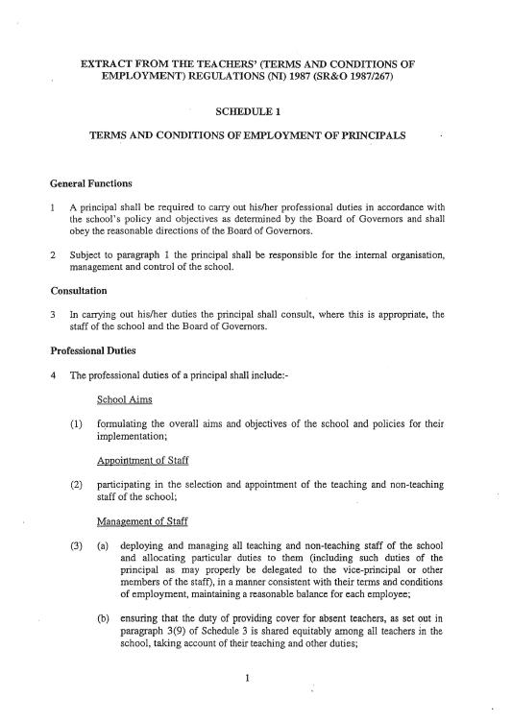

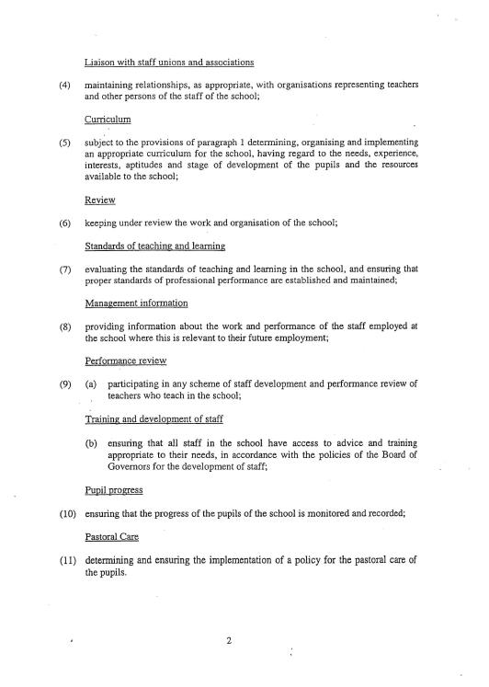

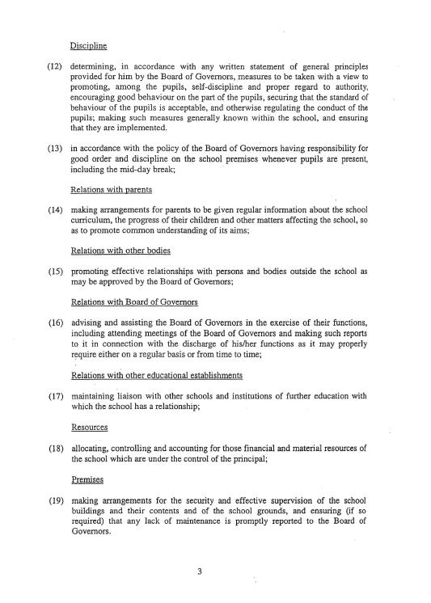

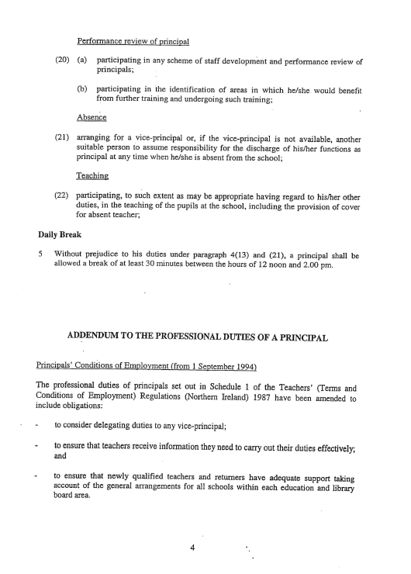

APPENDIX D

Extract of the Scheme of Management for Grant Maintained Integrated Schools

PART VI

FUNCTIONS OF THE PRINCIPAL

General

31. In addition to his statutory functions and subject to the provisions of the Education Orders and regulations, orders and directions made thereunder and to the provisions of this scheme and such directions as may, from time to time, be given to him by the Board of Governors, the Principal shall control the internal organisation, management and discipline of the school.
32. (1) Subject to a financial scheme under the Education Orders, the Board of
Governors may delegate to the Principal such of its functions in respect of the school for which the Principal is appointed, as it considers reasonable and desirable except functions relating to powers conferred or duties imposed by or under the following provisions -
a. Articles 4, 10 and 11 of the 1989 Order which relate to duties with respect to the curriculum.
b. Article 13(3A) and (3B) of the 1986 Order - appointment of parent governors - and Articles 122 or 139(5) of the 1989 Order - co-option of members to the Board of Governors.
c. Articles 31 of the 1989 Order and 17(3) of the 1997 Order which relate to the provision and publication of information.
d. Article 16 of the 1997 Order which relates to the criteria for selecting pupils for admission to the school.

e. Article 18 (2) (a) and (b) of this scheme which relates to the provision of a statement of general principles concerning
pupil discipline.

f. Article 49 of the 1989 Order as inserted by Article 39 of the 1993 Order which relates to the preparation of a scheme specifying procedures in relation to the suspension or expulsion of pupils.
g. Article 66(2) of the 1989 Order which requires the Board of Governors to use its best endeavours to ensure that the management, control and ethos of the school are such as are likely to attract reasonable numbers of both Protestant and Roman Catholic pupils.
h. Article 79 of the 1989 Order which relates to proposals for
significant changes to grant-maintained integrated schools.
i. Article 80 of the 1989 Order relating to the discontinuance of a
grant-maintained integrated school by the Board of Governors.

- Article 124(1)(b) of the 1989 Order which relates to the
provision of a statement of general principles concerning pupil
discipline.

k. Article 125 of the 1989 Order in so far as approval of the annual report of the Board of Governors is concerned.

l. Article 131 of the 1989 Order which relates to charges and
remissions policies.
m. Article 14 of this scheme, except in relation to the selection and
appointment of teachers to posts of less than one year’s duration.

n. Article 40(3) of this scheme which relates to the convening of
meetings.
o. Article 48 of this scheme which relates to the election of
Chair and vice-Chair of the Board of Governors.
- This Article of this scheme which relates to the delegation of
functions to the Principal.

(2) The functions to be delegated to a Principal under this Article shall not,
unless the Board of Governors otherwise determines, include the power to take decisions on behalf of or in the name of the Board of Governors without the approval of the Board of Governors.

Curriculum

33. In relation to the curriculum the Principal shall carry out the functions allocated to him under paragraph (4) of Article 17 of this scheme.

Communication

34. The Principal shall -
(1) promote regular communication between assistant teachers and
parents of pupils; and
  - maintain regular communication and consultation between himself and assistant teachers on the management of the school, curricular matters and on matters relating to the education, health and welfare and discipline of the pupils; and shall report to the Board of Governors on these matters as necessary or when so requested by the Board of Governors.

Delegated Functions

35. The Principal shall carry out any functions delegated to him by the Board of
Governors under Article 32 of this scheme and shall report any action or decision taken by him in relation to those functions to the next meeting of the Board of Governors or as soon as practicable thereafter.

Duty of Principal – Pupil Discipline

36. (1) It will be the duty of the Principal -
a. to determine measures (which may include the making of rules
and provision for enforcing them) to be taken with a view to -
(i). promoting, among pupils, self-discipline and proper
regard for authority;
(ii). encouraging good behaviour and respect for others on
the part of pupils;
(iii). securing that the standard of behaviour of pupils is
acceptable; and
(iv). otherwise regulating the conduct of pupils;
aa. before determining such measures, to consult the registered pupils at the school and the parents of those pupils.

b. in determining such measures -
(i). to act in accordance with the current statement made by
the Board of Governors under Article 18 (1); and

(ii). to have regard to any notification or guidance given to
him under Article 18 (3);
c. to prepare a written statement of such measures and to secure
that -

(i). a copy of that statement is given (free of charge) to the
parents of all registered pupils at the school; and
(ii). copies of the statement are available for inspection (at
all reasonable times and free of charge) at the school.

  - The standard of behaviour which is to be regarded as acceptable at the
school will be determined by the Principal so far as it is not determined by the Board of Governors.

Duty of the Principal – Pupil Suspension and Expulsion

(3) In determining the measures in relation to the suspension or expulsion
of any pupil the Principal shall -
    - act in accordance with the scheme prepared by the Board of Governors under Article 49 of the 1986 Order as amended by Article 39 of the 1993 Order and any written statement of general principles provided for him by the Board of Governors.
    - have regard to any guidance that the Board of Governors may offer in relation to particular matters.

Duty of the Principal – Staff Discipline

(4 ) a. The Principal shall be responsible to the Board of Governors
for the discipline of all staff employed by the Board of Governors at the school.

b. In carrying out his duties under sub-paragraph (4)a of this Article, the Principal shall act in accordance with –
(i). any disciplinary rules and procedures; and
(ii). any staff grievance procedures,

drawn up by the Board of Governors under Article 14(3) of this scheme.

c. The Principal may suspend any person employed by the Board
of Governors to work at the school where, in the opinion of the Principal, his suspension from school, is required.

d. The Principal, when exercising a power of suspension under sub-paragraph (4)c of this Article, shall immediately inform the Board of Governors.

e. Any suspension under sub-paragraph (4)c of this Article may only be ended by the Board of Governors.

Meetings of the Board of Governors and Committees Thereof

- Unless prevented from doing so by illness or other unavoidable cause and
subject to Articles 51, 52, 54 and 55 of this scheme, the Principal shall attend every meeting of the Board of Governors and of any committees established under Article 28 of this scheme of which he is a member. If the Principal is unable to attend a meeting of the Board of Governors or a committee of which he is a member he shall inform the Board of Governors of the reason for his inability to attend. In these circumstances the Board of Governors may require the assistance of a vice-Principal.

Resolutions of Annual Parents’ Meetings

38. When so requested by the Board of Governors the Principal shall comment in
writing on any resolution which is duly passed by an annual parents’ meeting and which the Board of Governors consider is a matter for him and report on any action he has taken thereon.
Mana

